# Introduction

Welcome to **E-Shop**, your ultimate destination for all things shopping! At E-Shop, we bring together a wide range of high-quality products and a user-friendly platform to make your shopping experience seamless and enjoyable. Our platform is designed to meet the diverse needs of our customers, from trendy fashion and tech gadgets to everyday essentials.

We are passionate about innovation, excellence, and customer satisfaction. By prioritizing your convenience, we ensure a smooth journey from browsing to checkout. Whether you're shopping for yourself or looking for the perfect gift, E-Shop is here to cater to your every need. Explore our curated collections, take advantage of exclusive deals, and join a community that values quality and trust.

E-Shop is more than just an online store—it's a lifestyle choice. Shop with confidence and discover why countless customers call E-Shop their go-to destination for online shopping.

## 1.1 Purpose of Project

The purpose of the **E-Shop Website Project** is to create a modern, user-friendly online shopping platform that not only showcases products but also strengthens the connection between the business and its customers through an enhanced **About Us** section. A well-designed About Us page plays a crucial role in building trust, communicating brand values, and humanizing the business.

By improving the About Us section, this project aims to:

1. **Highlight the Brand's Story**: Showcase the mission, vision, and journey of the company in a compelling manner to foster an emotional connection with customers.
2. **Showcase Team Members**: Introduce the team behind the brand to personalize the shopping experience, emphasizing the people driving the company's success.
3. **Enhance Trust and Credibility**: Provide transparency about the company’s values, goals, and dedication to quality and customer satisfaction, building trust with visitors.
4. **Encourage Engagement**: Use visually appealing layouts, intuitive navigation, and accessible content to keep customers engaged and encourage them to explore more of the site.

This project demonstrates the importance of storytelling and professional design in differentiating businesses in the competitive e-commerce landscape. A well-crafted About Us section ensures that E-Shop is not just a platform to buy products but also a brand that customers can relate to, trust, and return to for future purchases.

## 1.2 Project Objective

The primary objective of the **E-Shop Website Project** is to create an engaging and informative **About Us** section that enhances the overall user experience and establishes a stronger connection between the business and its audience. Recognizing the importance of the About Us page as a critical touchpoint, the project focuses on improving its content, design, and functionality to achieve the following goals:

1. **Communicate Brand Identity**: Present the company’s mission, vision, and values in a way that resonates with customers, fostering a deeper understanding of the brand.
2. **Build Trust and Transparency**: Showcase the company’s history, achievements, and team members to build credibility and create a sense of authenticity.
3. **Enhance User Experience**: Design a visually appealing and easy-to-navigate page that encourages visitors to engage with the brand and explore its offerings.
4. **Strengthen Customer Loyalty**: Use storytelling and personalization to create a meaningful connection, encouraging repeat visits and long-term loyalty.
5. **Drive Business Growth**: Position the About Us section as a strategic tool to differentiate the business, attract new customers, and retain existing ones in a competitive e-commerce market.

By achieving these objectives, the project aims to transform the About Us section into a powerful asset that reflects the company’s identity and inspires trust and confidence in its customers.

# **System Analysis**

The System Analysis for the E-Shop Website Project focuses on evaluating the existing system and identifying improvements to enhance the About Us section, which plays a key role in user engagement and brand perception. This analysis helps understand current limitations, determine user needs, and establish a roadmap for the redesign and implementation of the updated page.

Current System Evaluation:

1. Content Gaps: The previous About Us section lacked detailed information about the company's mission, vision, and team, resulting in a missed opportunity to build trust and communicate brand values effectively.
2. Design Limitations: The existing layout was static, outdated, and not visually engaging, leading to poor user engagement and reduced time spent on the page.
3. Navigation Issues: Inefficient placement and structure made the section less accessible, contributing to a disconnected user experience.

User Needs and Expectations:

1. Personalization: Customers expect relatable and authentic content that humanizes the brand, such as stories about the team and milestones.
2. Visual Appeal: Visitors are more likely to engage with pages featuring modern layouts, high-quality images, and a clean, organized design.
3. Mobile Responsiveness: With increasing mobile usage, users expect seamless functionality across devices.

Proposed Enhancements:

1. Content Improvements: Add detailed descriptions of the company’s mission, vision, and team to convey a clear and compelling narrative.
2. Interactive Design: Implement a visually appealing and responsive layout with features like team member profiles, animations, and call-to-action elements.
3. Accessibility and Navigation: Ensure the section is easy to find and navigate, with intuitive links and structured content hierarchy.

Expected Outcomes:

By addressing these limitations and implementing the proposed enhancements, the new About Us section will provide a richer user experience, strengthen brand credibility, and contribute to the website's overall effectiveness as an e-commerce platform. The improvements will align the page with user expectations and industry standards, ultimately driving engagement and customer loyalty.

## Requirements

The **Requirements** for the E-Shop Website Project outline the essential components needed to redesign and enhance the **About Us** section. These requirements address both functional and non-functional aspects to ensure a user-centric, visually appealing, and high-performing webpage that aligns with the objectives of the project.

**Functional Requirements:**

1. **Content Presentation**:
   * A detailed description of the company’s mission, vision, and values.
   * Profiles of key team members with images, names, and roles.
   * A section for the company’s history or milestones.
2. **Interactive Features**:
   * Hover effects on team member profiles for better engagement.
   * Call-to-action buttons, such as links to contact pages or social media.
3. **Navigation and Accessibility**:
   * Intuitive navigation with a clear link to the About Us section in the main menu.
   * Structured content for easy readability and skimmability.
4. **Responsiveness**:
   * Fully responsive design that works seamlessly on desktop, tablet, and mobile devices.

**Non-Functional Requirements:**

1. **Performance**:
   * Ensure fast loading times, optimized images, and efficient code to improve performance.
2. **Design Consistency**:
   * Maintain a cohesive style with the overall website design, including fonts, colors, and branding.
3. **Scalability**:
   * Build a flexible design that allows for future updates, such as adding new team members or achievements.
4. **Security and Privacy**:
   * Secure integration of links and features to protect user data.
5. **Usability**:
   * Ensure the section is easy to understand and navigate for users of all skill levels.

**Technical Requirements:**

1. **Technology Stack**:
   * HTML, CSS, and JavaScript for front-end development.
   * Integration with the existing website’s CMS or backend system.
2. **Testing and Validation**:
   * Cross-browser testing to ensure compatibility across major web browsers.
   * Mobile testing to verify responsiveness and usability.

By meeting these requirements, the updated About Us section will provide an enhanced user experience, strengthen brand identity, and serve as a valuable component of the E-Shop website.

## **Software Requirement**

**Software Requirements: E-Shop Website Project**

The **Software Requirements** for the E-Shop Website Project focus on the tools, technologies, and frameworks needed to design, develop, and maintain an enhanced **About Us** section. These requirements ensure the project is executed efficiently, aligns with the website's architecture, and meets modern web development standards.

**Front-End Requirements:**

1. **Languages and Frameworks**:
   * **HTML5**: For structuring the content of the About Us section.
   * **CSS3**: For styling, layout design, and responsiveness.
   * **JavaScript**: For adding interactivity and dynamic elements, such as hover effects or animations.
2. **Responsive Design Tools**:
   * Media queries to ensure compatibility across desktop, tablet, and mobile devices.

**Tools and Software:**

1. **Development Tools**:
   * Code editors: **Visual Studio Code**, **Sublime Text**, or **Atom**.
   * Version control: **Git** and **GitHub** for tracking changes and collaboration.

By leveraging these software requirements, the project ensures a smooth development process, robust performance, and a user-friendly design, resulting in an About Us section that is both functional and visually appealing.

3. Technology Used

3.1 HTML5

HTML5 serves as the backbone for structuring the E-Shop website, including the enhanced **About Us** section. Its features and capabilities are utilized to:

* Create semantic elements like <header>, <footer>, <section>, and <article> for better readability and accessibility.
* Ensure responsive design compatibility through the use of <meta> tags and flexible layouts.
* Embed multimedia elements such as images and videos without requiring external plugins.
* Support cross-platform functionality, ensuring the website works smoothly across various devices and browsers.

The use of HTML5 provides a modern, robust foundation for building the E-Shop website, ensuring scalability and compatibility with advanced web technologies.

3.2 CSS

**CSS (Cascading Style Sheets)** is used to style and enhance the visual presentation of the E-Shop website, including the improved **About Us** section. Its role in the project includes:

* **Design and Layout**:
  + Defining the layout of elements with properties like flexbox, grid, and positioning for a clean and organized structure.
  + Creating responsive designs using media queries to ensure compatibility across desktop, tablet, and mobile devices.
* **Styling Elements**:
  + Applying typography, including fonts, colors, and text styles, for a visually appealing and cohesive design.
  + Styling buttons, links, and interactive elements for an intuitive user experience.
* **Visual Effects**:
  + Adding animations and transitions for hover effects, smooth page interactions, and dynamic user engagement.
  + Enhancing the appearance of images and team member profiles with borders, shadows, and overlays.
* **Custom Themes**:
  + Maintaining brand consistency through a defined color palette, consistent spacing, and reusable CSS classes.

CSS allows for flexibility and creativity in the website’s design while ensuring a professional and polished look that meets modern web standards.

3.3 JavaScript

**JavaScript** is used to add interactivity and enhance the functionality of the E-Shop website, including the improved **About Us** section. Its role in the project includes:

* **Dynamic Content**:
  + Enabling dynamic updates to the page, such as interactive team member profiles with hover effects or modals displaying additional details.
* **User Interaction**:
  + Implementing interactive elements like drop-down menus, smooth scrolling, and clickable buttons for an engaging user experience.
  + Adding form validation for contact forms or newsletter signups, ensuring data accuracy before submission.
* **Animations and Effects**:
  + Enhancing user experience with animations, transitions, and fade-ins for a modern and polished look.
  + Creating engaging effects, such as image sliders or auto-scrolling testimonials, where applicable.
* **Responsive Design Enhancements**:
  + Adapting functionality dynamically based on screen size, ensuring the website remains user-friendly across devices.
* **Third-Party Integrations**:
  + Supporting the integration of APIs, such as social media widgets or analytics tools, to enhance functionality.

JavaScript adds life to the E-Shop website, making it more interactive and user-centric, ensuring visitors have a seamless and enjoyable browsing experience.

# 4. Output Screen

* 1. Home Page View.

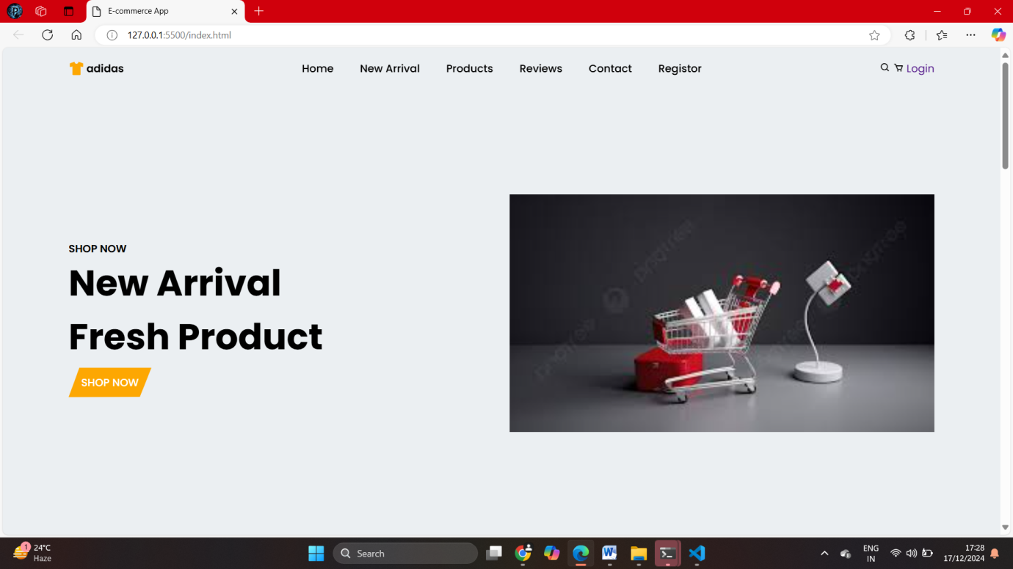

* 1. Product page view

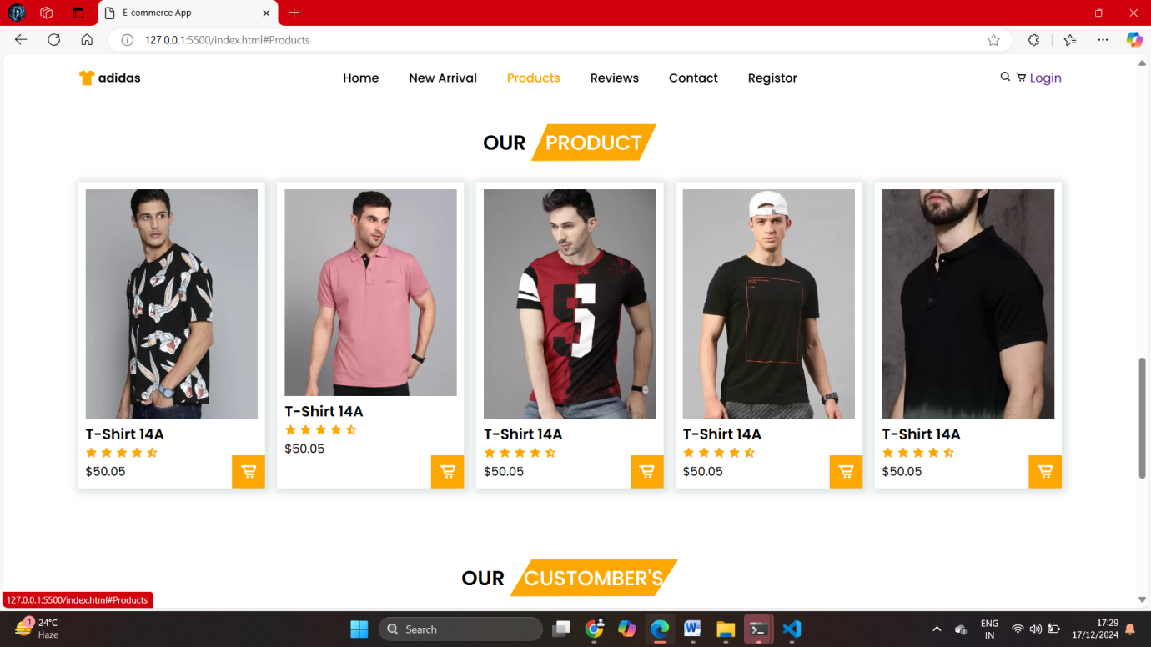

* 1. About us page View

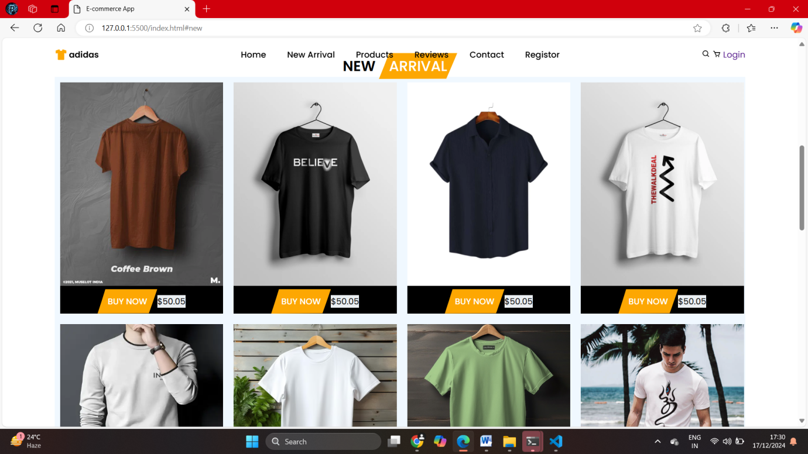

* 1. Login Page

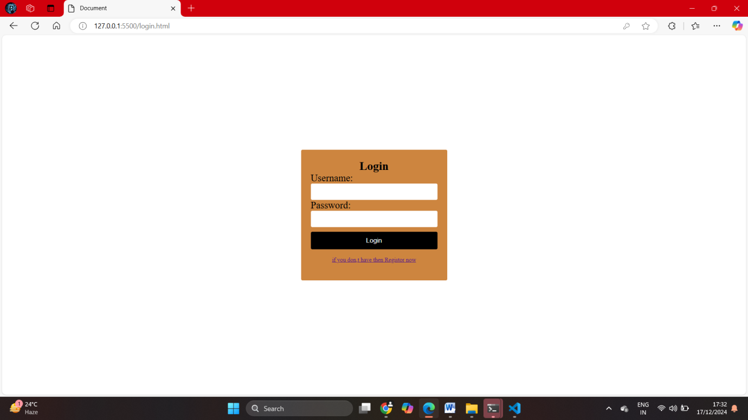

* 1. Registration page

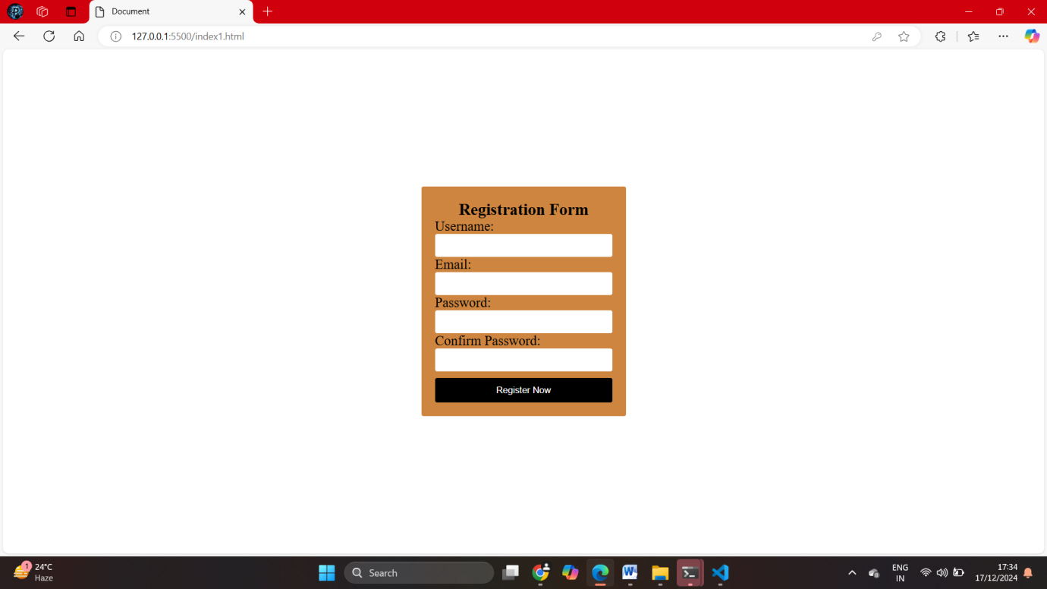

* 1. Contact

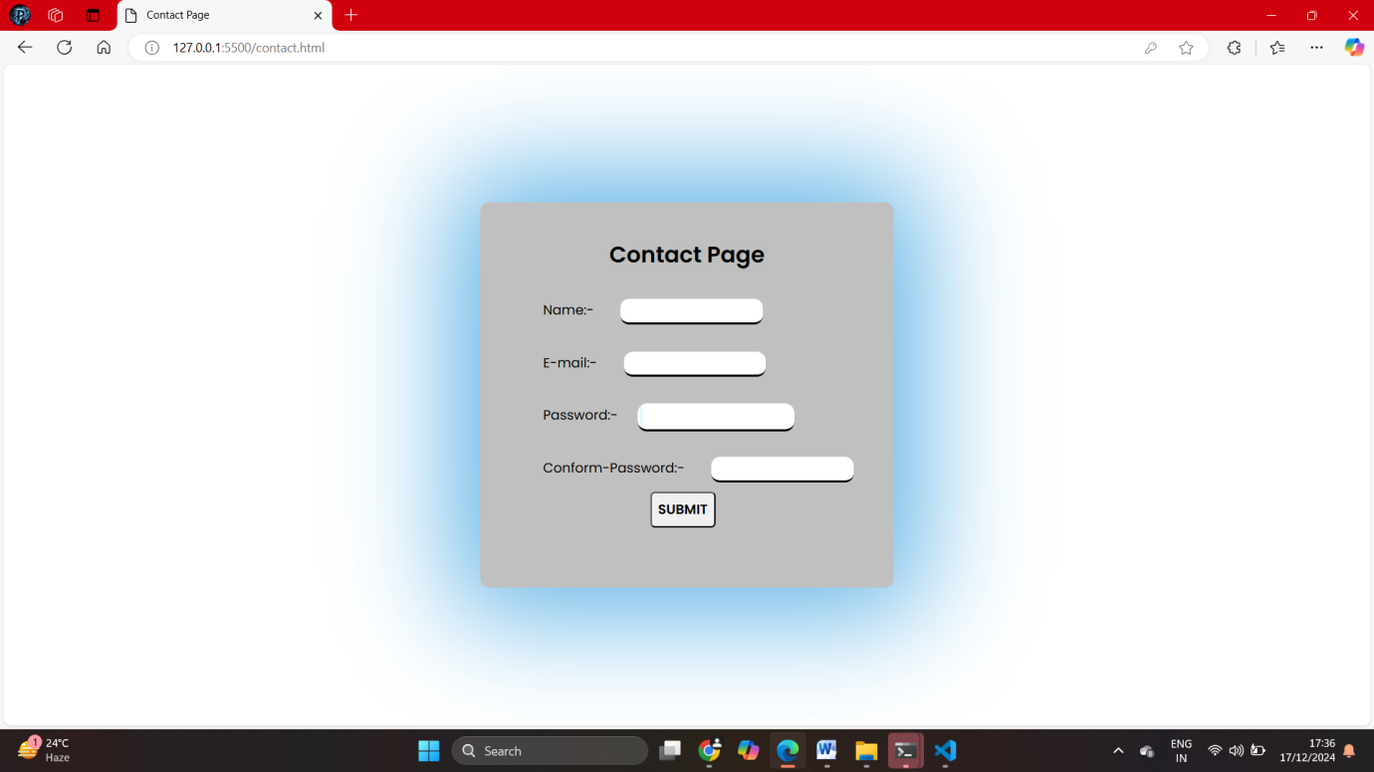

# Coding

The **E-Shop Website Project** utilizes a combination of **HTML5**, **CSS3**, and **JavaScript** to build a fully functional, user-friendly, and visually appealing e-commerce website. Here’s a breakdown of the coding used, its purpose, and where it applies:

**1. HTML5 (Structure and Content)**

HTML5 is used to create the **structure** and **content** of the website. It ensures that all elements are semantically well-defined for clarity, readability, and SEO optimization.

**Key Components in HTML:**

* **Document Structure**:
  + The basic structure of every page is defined using <!DOCTYPE html>, <html>, <head>, and <body>.
  + The <head> section includes metadata, page titles, and links to external CSS or JavaScript files.
  + <head>
  + <title>About Us</title>
  + <link rel="stylesheet" href="styles.css">
  + <script src="script.js"></script>
  + </head>
* **Semantic Tags**:
  + Tags like <header>, <nav>, <main>, <section>, and <footer> improve code structure and accessibility.
  + <header>
  + <h1><a href="index.html">E-Shop</a></h1>
  + <nav>
  + <ul>
  + <li><a href="index.html">Home</a></li>
  + <li><a href="products.html">Products</a></li>
  + </ul>
  + </nav>
  + </header>
* **Content Organization**:
  + Sections like **About Us** and **Team Members** are defined with <section> and <div> tags.
  + Team member details use <img> for profile pictures and <h4> or <p> for titles and descriptions.
  + <section class="team-grid">
  + <div class="team-member">
  + <img src="team1.jpg" alt="Team Member 1">
  + <h4>Jane Doe</h4>
  + <p>CEO & Founder</p>
  + </div>
  + </section>
* **Hyperlinks and Navigation**:
  + Links to navigate between pages use the <a> tag.
  + <a href="contact.html">Contact</a>
* **Responsive Meta Tag**:
  + Ensures the website scales properly on all devices.
  + <meta name="viewport" content="width=device-width, initial-scale=1.0">

**2. CSS3 (Styling and Design)**

CSS3 is used to enhance the **visual presentation** of the website, ensuring an aesthetically pleasing and responsive design.

**Key Components in CSS:**

* **General Styling**:
  + Basic styles for fonts, colors, spacing, and backgrounds are applied using global selectors.
  + body {
  + font-family: Arial, sans-serif;
  + margin: 0;
  + padding: 0;
  + line-height: 1.6;
  + color: #333;
  + }
* **Header and Navigation Styling**:
  + Flexbox is used to align navigation links, while hover effects add interactivity.
  + header {
  + background: #004080;
  + color: white;
  + padding: 10px 0;
  + }
  + nav ul {
  + list-style: none;
  + display: flex;
  + justify-content: center;
  + }
  + nav a {
  + text-decoration: none;
  + color: white;
  + padding: 10px 15px;
  + }
  + nav a:hover {
  + background-color: #0066cc;
  + }
* **Grid Layout for Team Members**:
  + A responsive grid layout is used to organize team member profiles.
  + .team-grid {
  + display: grid;
  + grid-template-columns: repeat(auto-fit, minmax(250px, 1fr));
  + gap: 20px;
  + margin-top: 20px;
  + }
  + .team-member {
  + text-align: center;
  + padding: 15px;
  + background: #f9f9f9;
  + box-shadow: 0 2px 5px rgba(0, 0, 0, 0.1);
  + border-radius: 5px;
  + }
* **Responsive Design**:
  + Media queries ensure the page looks good on smaller screens.
  + @media (max-width: 768px) {
  + .team-grid {
  + grid-template-columns: 1fr;
  + }
  + }
* **Footer Styling**:
  + Footer styles include social media links with hover effects.
  + footer {
  + background-color: #333;
  + color: white;
  + text-align: center;
  + padding: 10px 0;
  + }
  + .social-links a {
  + color: white;
  + margin: 0 10px;
  + text-decoration: none;
  + }
  + .social-links a:hover {
  + color: #00aced;
  + }

**3. JavaScript (Interactivity and Functionality)**

JavaScript is used to add **interactivity** and dynamic behaviors to the website, enhancing the user experience.

**Key Components in JavaScript:**

* **Interactive Hover Effects**:
  + Adding animations or pop-ups when users hover over team member profiles.
  + const teamMembers = document.querySelectorAll('.team-member');
  + teamMembers.forEach((member) => {
  + member.addEventListener('mouseover', () => {
  + member.style.transform = 'scale(1.05)';
  + member.style.transition = 'transform 0.3s ease-in-out';
  + });
  + member.addEventListener('mouseout', () => {
  + member.style.transform = 'scale(1)';
  + });
  + });
* **Dynamic Navigation Highlighting**:
  + Automatically highlight the active page in the navigation menu.
  + const currentPage = window.location.pathname;
  + const navLinks = document.querySelectorAll('nav a');
  + navLinks.forEach(link => {
  + if (link.href.includes(currentPage)) {
  + link.classList.add('active');
  + }
  + });
* **Smooth Scrolling**:
  + Enable smooth scrolling for anchor links.
  + document.querySelectorAll('a[href^="#"]').forEach(anchor => {
  + anchor.addEventListener('click', function (e) {
  + e.preventDefault();
  + document.querySelector(this.getAttribute('href')).scrollIntoView({
  + behavior: 'smooth'
  + });
  + });
  + });
* **Responsive Features**:
  + Adjust behavior dynamically for smaller screens or add mobile-specific functionality.

**Summary of Technologies and Roles:**

1. **HTML5**: Provides the **structure** and content for the website.
2. **CSS3**: Handles the **styling**, layout, and responsiveness to ensure a visually appealing design.
3. **JavaScript**: Adds **interactivity** and dynamic functionality, enhancing user engagement.

Together, these technologies work seamlessly to deliver a functional, responsive, and visually appealing **E-Shop website** with an improved **About Us** section that effectively communicates the company’s mission, vision, and team.

# Conclusion

1. The **E-Shop Website Project** successfully demonstrates the integration of modern web development technologies to create a user-friendly, visually appealing, and responsive website. By enhancing the **About Us** section, the project effectively highlights the company's mission, vision, and team, providing visitors with a clear understanding of the organization.
2. The use of **HTML5** for structure, **CSS3** for styling and responsive design, and **JavaScript** for interactivity ensures that the website meets modern standards of web development. The improved About Us section reflects a balance of aesthetics, usability, and functionality, contributing to better user engagement and a professional online presence.
3. This project showcases how focused improvements to specific sections of a website can enhance overall user experience, improve brand communication, and align with business objectives. Through careful planning, analysis, and implementation, the E-Shop website now stands as an example of clean design, organized content, and robust functionality.

# Future Improvement

The **E-Shop Website Project** lays a solid foundation for a functional and engaging website. However, there are several areas for future improvement that can further enhance the website's performance, user experience, and scalability:

**Dynamic Content Management**:

Integrate a Content Management System (CMS) like WordPress or a custom-built backend to allow non-technical users to update the About Us section easily.

**Enhanced Team Profiles**:

Add interactive features such as modals or detailed pop-ups to provide more information about each team member.

Include video introductions or testimonials to create a more personalized experience.

**SEO Optimization**:

Improve search engine visibility by implementing advanced SEO techniques, such as structured data, alt tags for images, and keyword optimization.

**Analytics Integration**:

Incorporate tools like Google Analytics or Hotjar to track user engagement with the About Us page and identify areas for further optimization.

**Localization and Accessibility**:

Make the website accessible to a broader audience by supporting multiple languages and ensuring WCAG compliance for users with disabilities.

**Mobile-First Enhancements**:

Further optimize the mobile version of the website with touch-friendly navigation, faster load times, and mobile-specific layouts.

**Performance Optimization**:

Use techniques like lazy loading for images, minifying CSS/JavaScript files, and implementing caching strategies to improve website performance and speed.

**Social Media Integration**:

Enhance the About Us section with live social media feeds, clickable social proof (e.g., customer testimonials), or direct links to the company’s profiles.

**Customer Feedback**:

Add a feedback or testimonial section to the About Us page, allowing customers to share their experiences and further build trust.

**AI-Powered Features**:

Incorporate AI-based chatbots or recommendation systems to personalize user interactions and guide visitors more effectively through the website.

By addressing these potential improvements, the E-Shop website can evolve into a more robust, engaging, and future-ready platform that consistently meets user needs and aligns with business goals.